ETL Project

The purpose is to collect the top grossing movies for each of the studios. The site provides information abut the highest grossing movies by studio as seen in the screenshot below

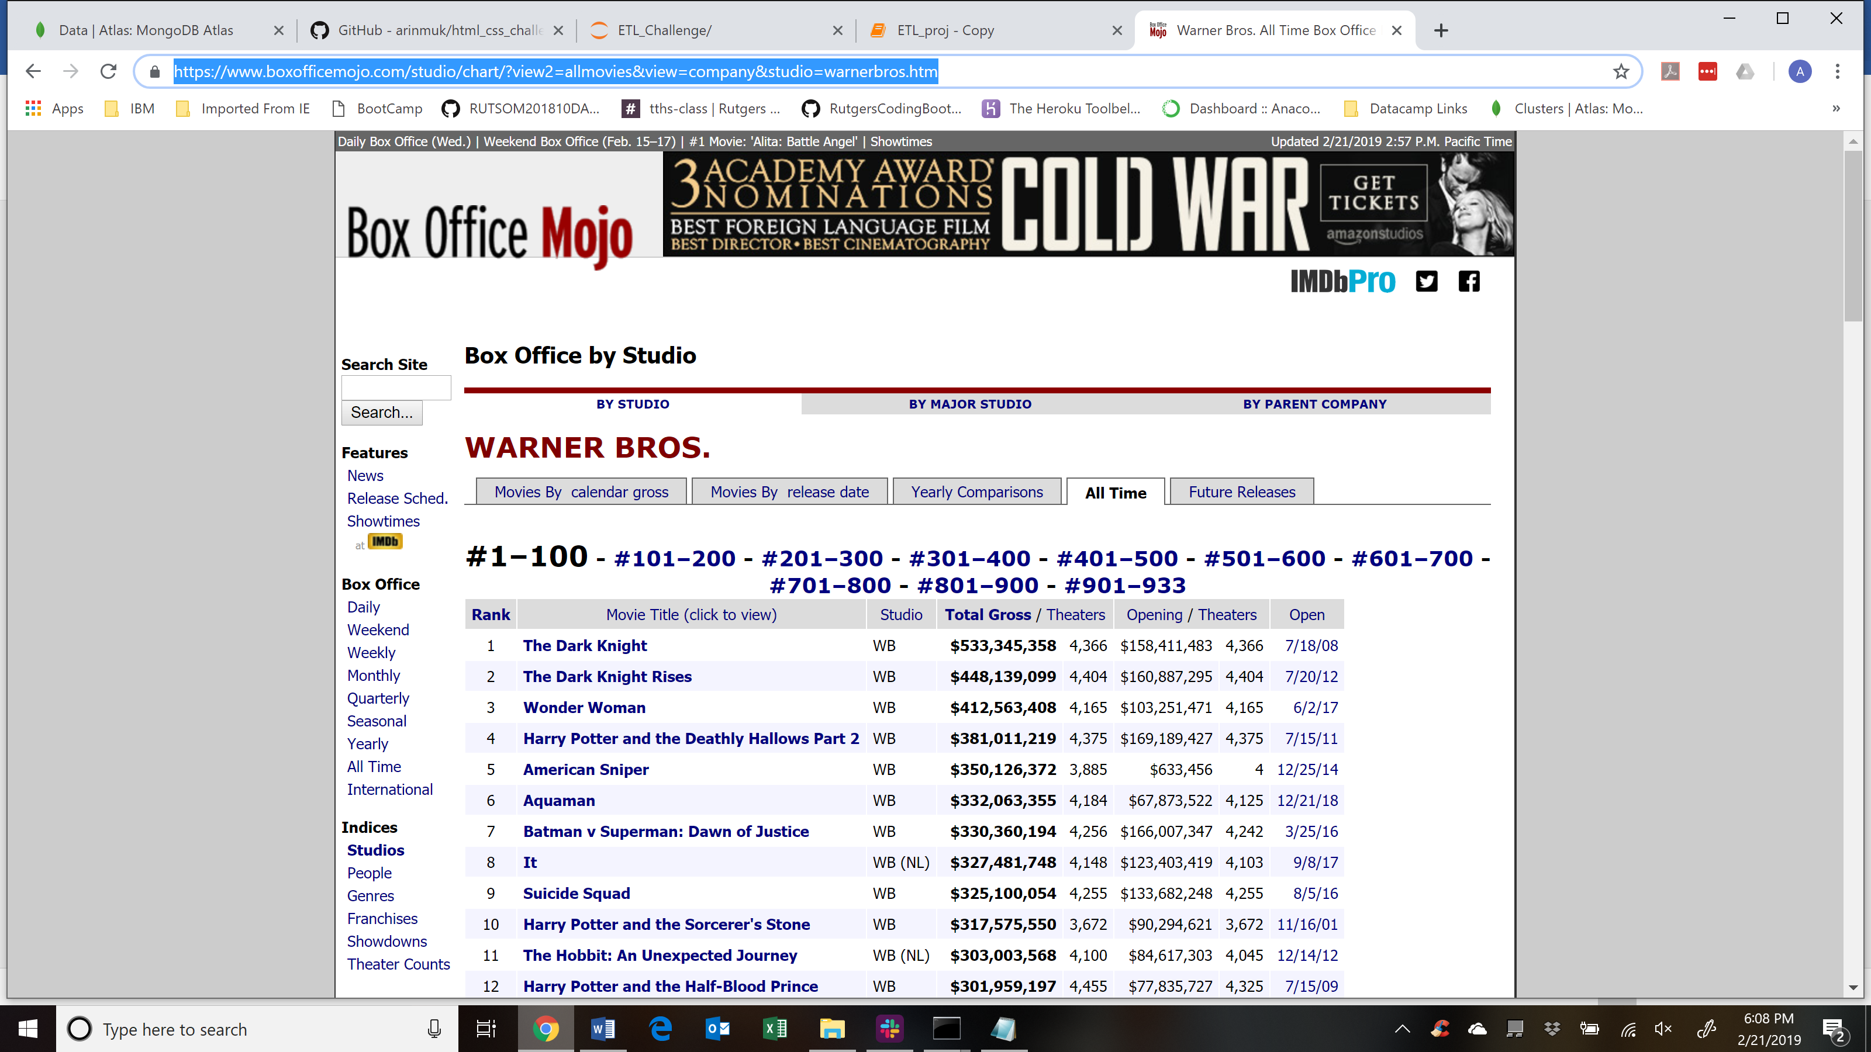

<https://www.boxofficemojo.com/studio/chart/?view2=allmovies&view=company&studio=warnerbros.htm>

The fields returned are Rank, Movie Title, Studio, Total Gross, Theater Count, Opening Day gross, Opening Day theater release count, and date it was released first. Use of splinter was not possible since each of the studios had 100s of releases over several years. Each page per studio has a hundred movie records and there were several pages of records for each studio as is also seen above in the screenshot.